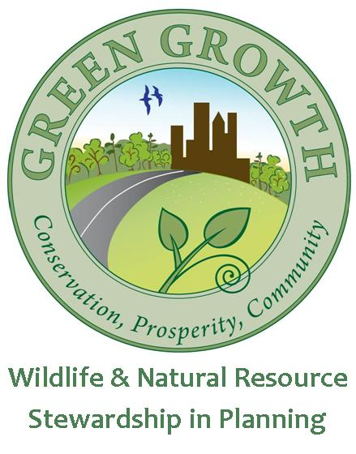
Preferred development design guide
  - A product of the NC Wildlife Resources Commission Green Growth Toolbox (www.ncwildlife.org/greengrowth)

Overview
North Carolina Communities have expressed interest in providing developers with preferred development design standards. These voluntary standards can improve development and wildlife habitat conservation. The principles and steps of conservation design are provided here. For detailed information about conservation of priority wildlife habitats and maps of priority habitats, including the map layers mentioned here see the NCWRC Green Growth Toolbox and Handbook.

Development location
- Select an appropriate site for the type of development. Appropriate, green sites for major development are:
- Centered around towns and cities such that urban or suburban areas will not spread extensively into rural areas.
- Not adjacent to Managed Areas (conserved lands) or taking up more than 50% of the area of ‘priority wildlife habitats’ on site.
- On land that has already been disturbed recently.
- And those that do not cut through wildlife habitat corridors.

Map and set-aside natural open space
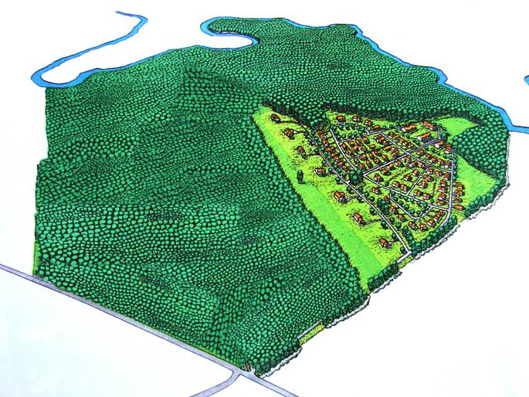
- Minimize wildlife habitat fragmentation
When mapping upland and wetland habitats to set-aside as natural open space it is important that these areas are as large and as wide on all sides as possible. If narrow habitat corridors are unavoidable, they should be at least 150 feet wide and ideally more than 330 feet wide. Natural open space on-site should connect to natural open space on adjacent sites.
Conservation development design. (Randal Arendt)
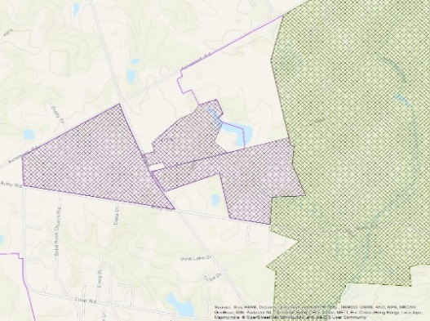
- Set development back from the borders of protected lands (Managed Areas map layer)
Private lands where habitat conservation is important to reduce ‘edge effects’. Boundaries in purple above have more edge than those in red. If these areas are conserved habitat edge is minimized
Managed Areas
More edge
Less edge

It is important to set development back as far away as possible from protected lands to maintain habitat quality and the ability to manage habitats using tools such as prescribed burning. Inhabited structures adjacent to protected lands make it difficult to manage habitats.

- Design natural open space to provide wildlife core habitat and travel corridors to conserve the following:
- Habitat for federally protected species, such as bald eagles
- Natural Heritage Natural Areas
- Priority wildlife habitats identified in the N.C. Wildlife Action Plan
- Forests bordering wetlands, streams or rivers
- Natural open spaces that connect or buffer existing protected natural areas
See Section 3 of the Green Growth Toolbox Handbook for recommendations on how habitat to set aside.
What are Edge Effects?
Unnatural predators are among the multitude of threats to priority wildlife. Domestic cats do not typically venture deep into natural habitat areas, but patrol the edge looking for the next bird to lay on your doorstep.

- Create a map of important upland and wetland habitats on and adjacent to the site.
- Include Conservation Data for Green Growth on the development sketch, preliminary and final plans. Include areas adjacent to the site. These data are available at www.ncwildlife.org/greengrowth,
- The following map layers are the most important to include: floodplains, streams, wetlands, Natural Heritage Natural Areas, and Natural Heritage Element Occurrences.
- Delineate the boundaries of natural open space that will be conserved on site. The boundaries can be partially mapped through analyzing aerial photos, but field surveys are best to fully delineate boundaries.
- Development should not surround natural open space. Ideally natural open space will comprise an entire undeveloped portion of the site whereby development does not penetrate into natural open spaces.
- Include an aerial photo
- In suburban and urban areas it is essential to conserve wetland and stream buffers, but it is usually better for wildlife to put as much development on one site as possible by developing the uplands. Remember to use Low Impact Development practices.

Ownership and habitat management
- The homeowner’s association can become the owner of the common natural open space. Homeowners association fees can cover property taxes and habitat management.
- It is important to permanently protect natural open space, ideally by donating the development rights in a conservation easement. Such a donation also provides the landowner with significant income tax relief. If an easement is not possible, deed restrictions can be documented.
- It is important to manage habitats so they are not polluted and are kept in their natural state. See Section 3 of the green growth toolbox for management recommendations.

Construction and post construction

Tree Protection
- In developed areas maintain as close to a contiguous tree canopy as possible.
- Retain native, mature trees. Consult the Audubon Bird -Friendly Communities program website below for lists of native plants and trees. Some tree species at maturity, such as long-leaf pine, have very small diameters. Make sure to specify the correct diameter of trees to retain, so you don’t lose mature trees.
- Retain as much shrub understory as possible and remove non-native plants.

Treat Stormwater on-site with Low Impact Development
- Create a plan to minimize grading, especially next to wetlands, waterways, and steep slopes and maintain as many trees and as much natural vegetation as possible. Clearly mark areas that should not be graded.
- Perform clearing and grading that follows a stream protection strategy.
- Low Impact Development (LID) techniques use natural vegetation and topography to treat stormwater on site. Reducing the need for large stormwater ponds provides space for additional lots.
- Remember not to direct polluted stormwater into natural habitats.
- For detailed LID techniques see:
  - N.C. State University Low Impact Development Guidebook and training
www.onsiteconsortium.org/npsdeal/NC_LID_Guidebook.pdf
- Coastal LID
www.nccoast.org/uploads/documents/guides/LIDNC.pdf
- Brunswick County: www.brunswickcountync.gov/engineering/stormwater/
- Brunswick County Extension:
https://brunswick.ces.ncsu.edu/site-brunswick-the-responsible-homeowner/
- Cost benefit information
    - www.epa.gov/owow/NPS/lid/
    - www.unh.edu/unhsc/forgingthelink
  - Stormwater Manager’s Resource Center - www.stormwatercenter.net
- Smart Yards, NC Coastal Federation: http://www.nccoast.org/uploads/documents/Media%20Room/Special%20publications/SmartYardsGuide_8-14_issue.pdf
- Phase construction to reduce the area and time over which soils are disturbed.
- Stabilize soils as quickly as possible (< 2 weeks) by establishing a native grass or
mulch cover.
- Establish appropriate perimeter controls at the edge of construction sites to retain or filter concentrated runoff from relatively short distances before it leaves the site.

Landscape with native plants

Resources for available native plants
- Native plant landscaping and maintaining natural vegetation is much less expensive to maintain then lawns and exotic plants. Native plants are better adapted to our climate and drought.
- NC Audubon Bird Friendly Communities has excellent native plant lists and works with local landscaping companies to make ‘native plants of the year’ available for larger scale landscaping. http://nc.audubon.org/conservation/bird-friendly-communities/bird-friendly-native-plants

